OLIVER’S BATTERY LONG TERM CURRICULUM OVERVIEW – 2022/23
Whilst some seasonal drivers are planned for each year the majority of themes are based on observations of the children’s interests. Key texts are chosen that support these themes
Year Group: R | Autumn 1 | Autumn 2 | Spring 1 | Spring 2 | Summer 1 | Summer 2
Seasonal drivers | Starting school Getting to know you  Autumn | Halloween  Bonfire Night  Remembrance Sunday  Christmas | Winter  Chinese New Year  Mental Health Week | Spring  Shrove Tuesday  World Book Day  Science Week  Easter | Summer | Moving up
Themes  Based on seasonal drivers and children’s interests | Starting school  Changing seasons - leaves | Witches Kitchen  Birthdays  Pirates  Christmas | Winter  Pets  Vets  Zoos  Chinese New Year | Traditional Tales – what was life like in the past? | What’s in our pond? (tadpoles)  Hatching eggs  Looking after our world? | Growing up  Babies and Parents – animals and human  Caterpillars  What’s it like to live in a different country?  What do grown-ups do all day?
Key texts | 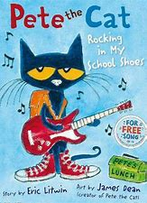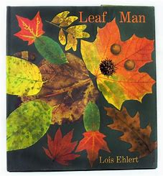 | 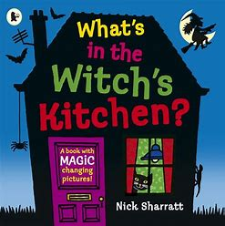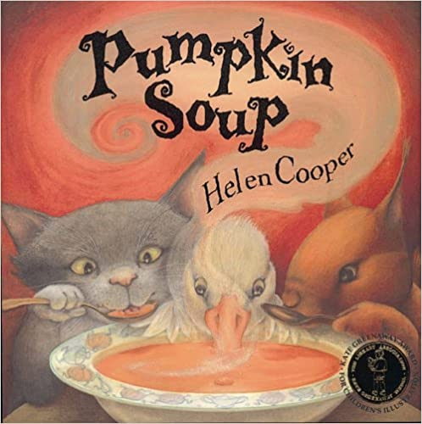  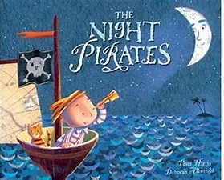 | 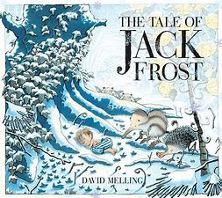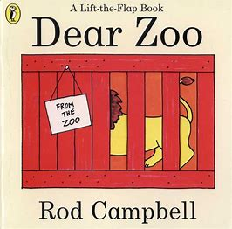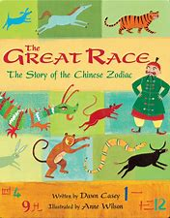 | 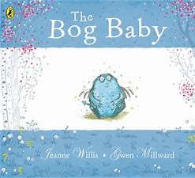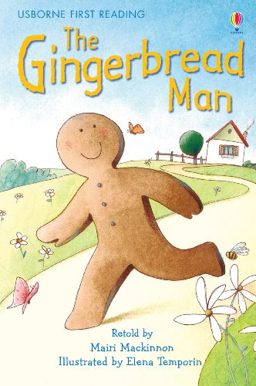 | 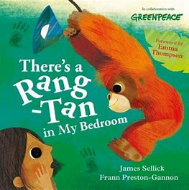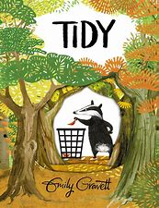  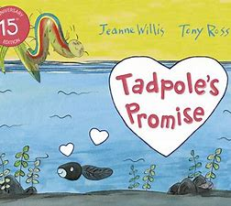 | 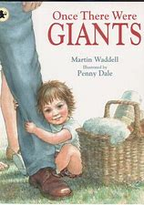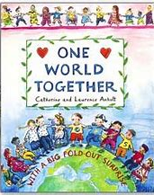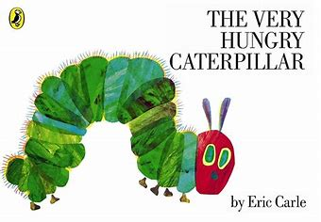
Phonics | Phase 1/2 | Phase 2 | Phase 3 | Phase 3 | Recap Phase 3 | Phase 4
Maths  (WRH) | Just like me  It’s me 1, 2, 3  Sorting  Matching  Introduce 1-3  Introduce Subitizing  Length  Books to support:  The Button Box  Anno’s counting book | It’s me 1, 2, 3  Light and Dark  Comparing quantities more/less  2D shape: Circles, Triangles, Squares and Rectangles  4 & 5  Ordering 1-5  Partitioning number to 5  Number Bonds  Books to support:  Anno’s counting book  Pete the Cat & his 4 groovy buttons  Kipper’s Birthday | Alive in 5!  Growing 6, 7, 8  Zero  Partitioning number to 5  Number Bonds  6, 7, 8  Weight, capacity, length & height  Books to support:  Six Dinner Sid | Building 9 & 10  Consolidation  To 20 and Beyond  8, 9, 10  Partitioning number to 10  Number Bonds  3D shape: spheres, cubes, cuboids, cones  Build & identify numbers 10-20 | First, now, then  Find My Pattern  Identify patterns in numbers 10-20  Addition  Subtraction  Capacity  Number bonds  Addition  Subtraction  2D shapes  Doubling  Sharing  Odds and Evens  Books to support:  Mr Gumpy’s Outing  Kipper’s Toy Box | On the Move
RE  Christianity and Judaism |  | Jesus’ birth | Celebration  Chinese New Year | New life at Easter |  | Special clothes
Understanding the World | TNW  Seasonal changes - Autumn | PCC  Know some similarities and differences between different religious  and cultural communities in this country | TNW  Exploring Ice  P&P  Roles in society: Vet  PCC  Know some similarities and differences between different religious  and cultural communities in this country | P&P  How have we changed since we were babies?  Understanding the past through stories – looking at ovens/cooking in traditional tales  TNW  Exploring and observing the natural world (tadpoles)  Explore floating and sinking – make a boat for the Gingerbread Man  PCC  Know some similarities and differences between different religious  and cultural communities in this country | TNW  Exploring and observing the natural world (tadpoles, caterpillars & hatching eggs)  PCC  Know some similarities and differences between different religious  and cultural communities in this country  P&P  Talk about the lives of people around us – their roles in society | PCC  Similarities and differences between life in this country and life in other countries  TNW  Similarities and differences between the natural world around them and contrasting environments  Exploring maps
Expressive Arts & Design | Transient art self portraits  Colour Mixing –autumn colours  Leaf man pictures | CwM  Kandinsky – circle & triangle pictures (linked to Maths)  Poppies  Christmas cards  Calendars  BI&E  Nativity | CwM  Sculpture: Playdough, papier mache  BI&E  Role play  Lion Dance (links to UtW) | CwM  Observational drawing and painting: Daffodils & spring flowers  Matisse – ‘Snail’ – collaborative art using multi media  BI&E  Vet roleplay | CwM  Observational drawing and painting: Tadpoles, caterpillars, chicks | CwM  Symmetrical printing with paint (links to Maths)
Charanga Music | Me! | My Stories | Everyone! | Our World | Big Bear Funk | Reflect, Rewind & Replay
Physical development | Pen Disco/Dough Disco | Pen Disco  Funky Fingers groups according to assessment | Pen Disco  Funky Fingers groups according to assessment | Pen Disco  Funky Fingers groups according to assessment | Pen Disco  Funky Fingers groups according to assessment | Pen Disco  Funky Fingers groups according to assessment
PSED/RR | ‘No Outsiders Here’  You choose- Nick Sharratt & Pippa Goodheart – ‘We all like different things’  Red rockets and rainbow jelly- Sue Heap and Nick Sharratt - We like different things, we are friends | ‘No Outsiders Here’  Blue Chameleon- Emily Gravett - I don’t have to change  Hello Hello by Brendan Wenzel - Use my pupil voice  Ten little pirates- Mike Brownlow and Simon Rickerty - Boys and girls can play together | RR: What is a right  Wants vs Needs  Class Charter:  19 We have the right to be safe  28 the right to learn  31 The right to play |  | Resilience – building card towers etc | ‘No Outsiders Here’  Mommy Mama and me- Leslea Newman, Carol Thompson - To talk about my family
PE | Body awareness  Children are body aware.  Gymnastics  Show good control and body co-ordination. | Body awareness  Children have a spatial awareness  Dance  Move confidently in a range of ways. | Gym – Basic Shapes  Can show how the body can make different shapes.  Basic ball skills  Can show control of a ball. | Dance  Children can move and react to the music.  Basic ball skills  Can send a ball into a space and towards a target. | Gym – Travelling  Can travel and then hold (balance) a shape.  Athletics  To know the importance of good health and exercise. | Team Games  Child can show an awareness of space, adjusting speed and direction.
Forest School | Introduction to Forest School | Introduce fire  Safety  Using a flint & steel | Cooking on a campfire | Spring  Goldsworthy art  Making bird feeders  Making seed bombs | Hapa Zoma  Making a nest for an orangatan  Using Tools | Summer  Elder Tree  Using Tools  Map of Forest School

